Information on Black Lights Astrology
Black Lights Astrology (BLA) finds its roots in the French astrologer Dom Neroman. The approach was extended by another French astrologer: Jean Carteret. It was the Dutch astrologer George Bode who gave BLA it's final form. Currently, the technique is mostly used in The Netherlands.
This description is extremely short. If you want more information you can read the books by Charlotte Wenner, a series of which the first book has been published: Structural Noetic Astrology: Part 1. If you can read Dutch, I can recommend the books by George Bode.
The most important elements of BLA:
- the use of the empty focal points in the Keplerian ellipses that are formed by the celestial bodies: the Black Moon and the Black Sun. Astronomically, these are the aphelion for the Sun and apogee for the Moon.
- introduction of two hypothetical planets: Persephone and Vulcanus.
- introduction of points that form oppositions or squares with the Lunar nodes or with the aphelion and apogee.
- a redefinition of the rulerships.

Black Moon
The Black Moon is the apogee, the point in the lunar orbit that is at the most remote point from earth. This point coincides with the empty focal point in the orbit of the Moon.
Because the orbit of the Moon is highly irregular, corrections have been introduced to calculate the Corrected Black Moon. The most popular approach is from Max Duval, who unfortunately did not explain his approach nor give any formula. We only have his printed ephemeris. The Dutch astrologer Cees Jansen succeeded in the construction of a formula that mimics the values of Duval very closely, mostly within a minute of arc, but always within 3 minutes of arc.
The Swiss Ephemeris provides an alternative approach that uses the theory of the Moon that is the astronomical standard.
BLA uses both the Mean Black Moon and the Corrected Black Moon.
The Black Sun is the aphelion, the point in the orbit of the earth around the Sun that represents the empty focus point in the ellipse. The position of the Black Sun changes very slowly.

Persephone and Vulcanus
Jean Carteret introduced the hypothetical planets Persephone and Vulcanus that should have an orbit outside of Pluto. An ephemeris for these points exists but the positions are astronomically impossible as the laws of Kepler nor retrogradation are taken into account. The effect of retrogradation should be large because of the remote positions of these hypotheticals. The hypotheticals can be seen as symbolic points with no material existence.
The ephemerides cover about a century but Enigma extrapolates the positions for other periods. As the movement is 100% uniform, this does make sense.

Additional points
BLA uses several other points that have a position relative to one of the existing positions. In the table you will see all points, a description and a short meaning.
Point | Definition | Short meaning
Persephone | Hypothetical point | Relates to Pluto as Venus relates to Mars. Communication.
Vulcanus | Hypothetical point | Comparable to Mercury. Coordination.
Black Moon | Mean apogee in the orbit of the Moon | Unicity, introversion, absorbs but does not reflect (like the Moon does).
Corrected Black Moon | The apogee of the Moon with corrections for disturbances | As the Black Moon
Priapus | Mean perigee of the Moon (opposite to the Black Moon) | Opposite meaning of the Black Moon, as the Moon but more explicit.
Corrected Priapus | The perigee of the Moon with corrections for disturbances (opposite to the corrected Black Moon) | As Priapus
Black Sun | Aphelion in the orbit of the Earth around the Sun | Opposite meaning as the Sun. Anti-authority, chaos.
Diamond | Perihelion of the Sun (opposite to the Black Sun) | Very much like the Sun, but more explicit. Counterpart of the Black Sun.
Dragon | The point that forms a square with the Northern Lunar Node, in the direction of the signs | The hard armor of the ultimate possible form of consciousness.
Beast | The point that forms a square with Northern Lunar Node, in the direction opposite to the direction of the signs. | Opposite to the Dragon: pure life, consuming everything.

Glyphs as used in BLA
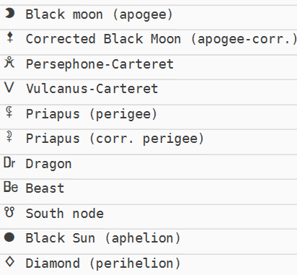

Rulerships
In BLA, the rulerships differ strongly from the usual approach. Each sign has two rulers, a main ruler and a sub ruler.
Each ruler pair rules two signs, but they exchange the roles of mainruler and subruler.
Sign | Main ruler | Sub ruler
Aries | Mars | Pluto
Taurus | Venus | Persephone
Gemini | Mercury | Vulcanus
Cancer | Moon | Priapus
Leo | Sun | Black Moon
Virgo | Vulcanus | Mercury
Libra | Persephone | Venus
Scorpio | Pluto | Mars
Sagittarius | Jupiter | Neptune
Capricorn | Black Moon | Sun
Aquarius | Priapus | Moon
Pisces | Neptune | Jupiter

